**CS5542 – Big Data Analytics and Apps**

**Lab 5 – Assignment Submission**

Name: Lava Kumar S

Class ID : 38

**Task 1**  
Create your own dataset for Image Classification Problem. Use the workflow as discussed in the Tutorial 4 Session using any classification algorithm (e.g., Random Forest, Naïve Bayes) excluding Decision Tree. Report the accuracy and confusion matrix obtained.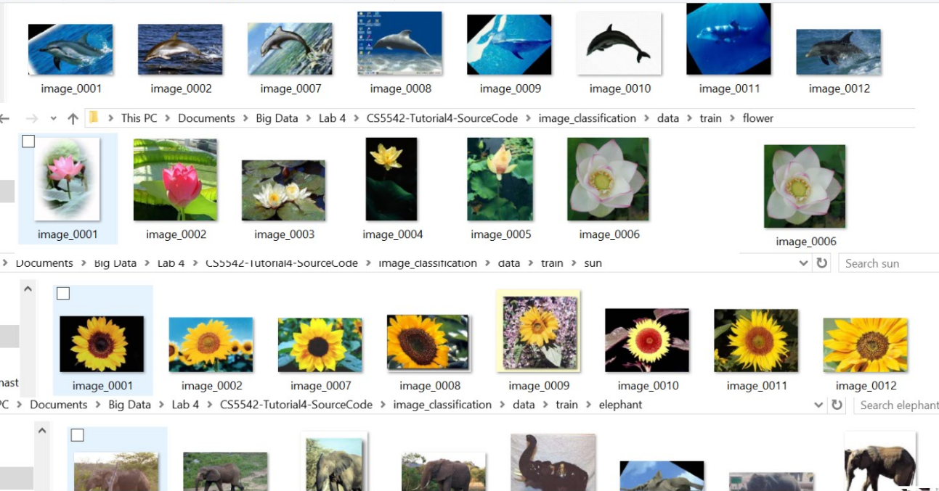

**Image Classes**  
Four classes are taken as image categories.They are "dolphin","elephant","sun",flower".  
  
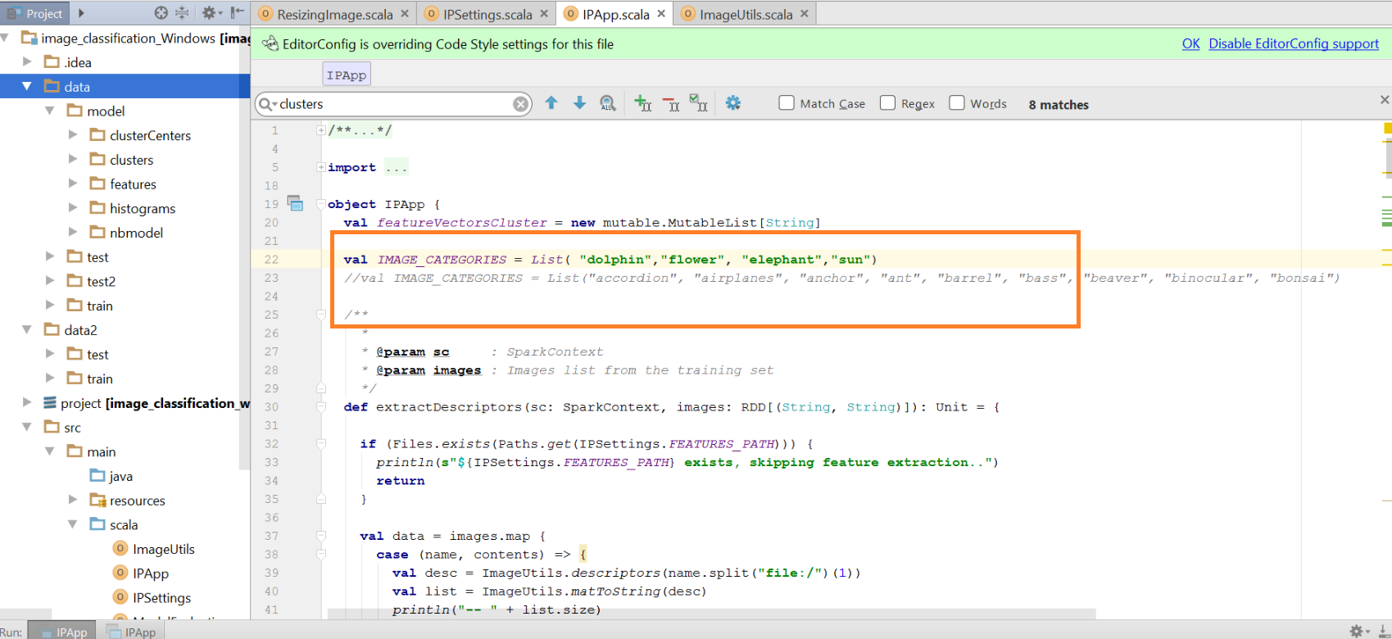

**Models Generated**  
After performing extraction, clustering, Histogram creation and classification the models are saved.  
  
  
**Test Data**  
Then the test data is passed to find the accuracy.  
  
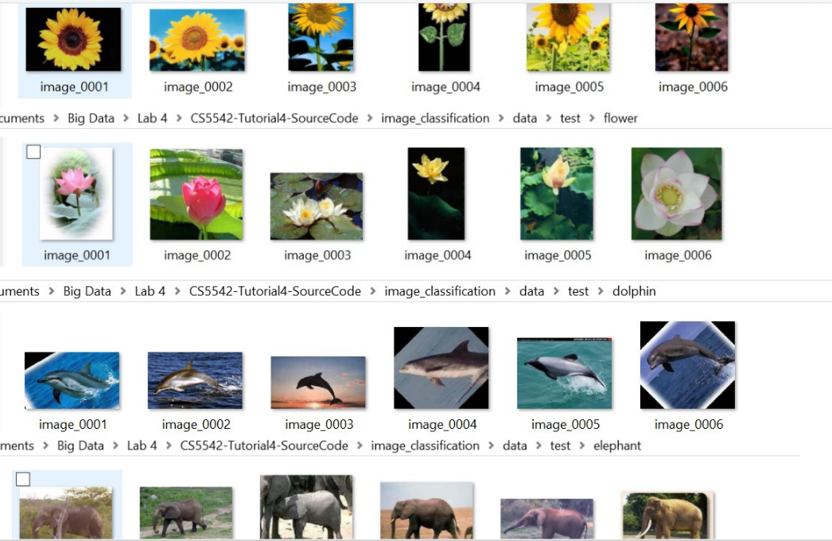

**Confusion Matrix**  
Finally confusion matrix is created for evaluating the performance and if the classification was done correctly.  
  
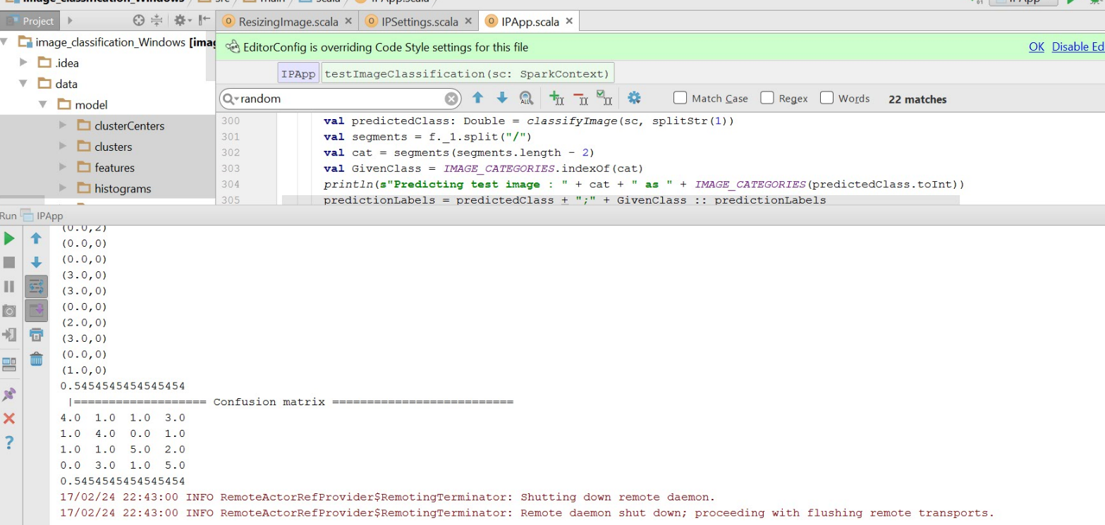

**Task 2**  
Write a client application using the Spark API to connecting between Spark and your client. Your client can be either Web application or Android application. Refer to Tutorial 5 Spark API tutorial.  
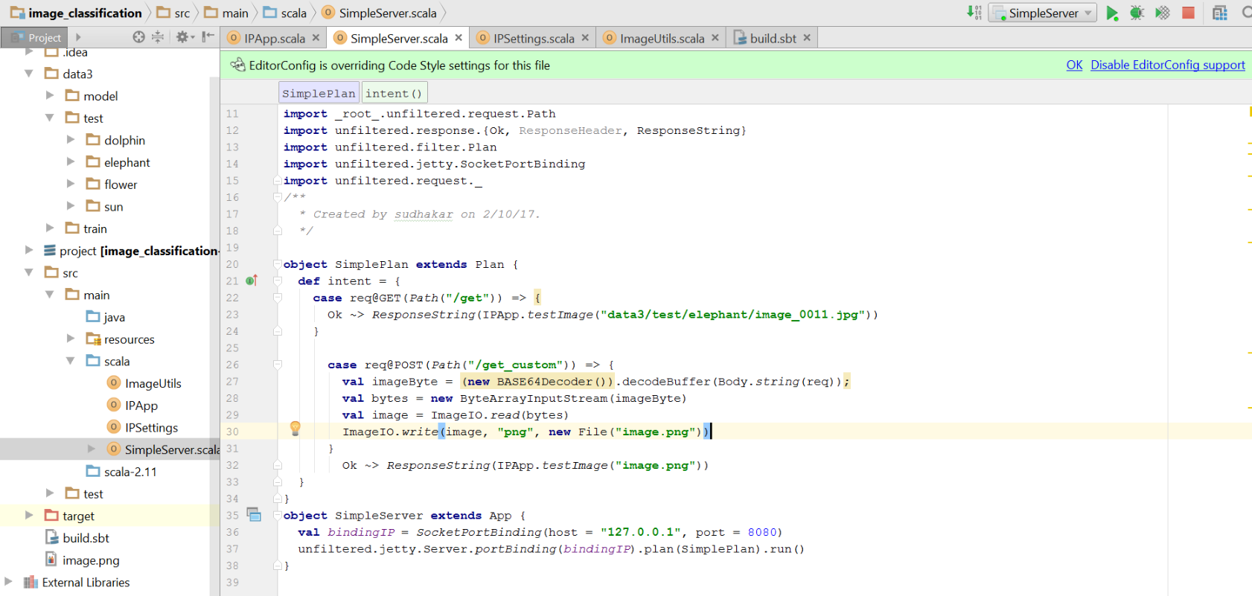  
**Client Application**  
After the client has connected the application predicts the image and the proccessing is done in the server program and displayed in the html page.  
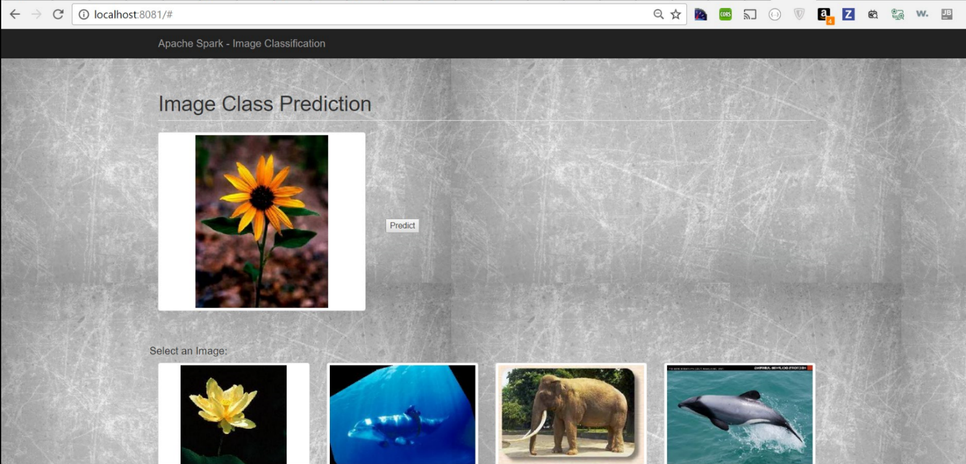  
Lets predict the sunflower.After clicking the button processing takes place.  
  
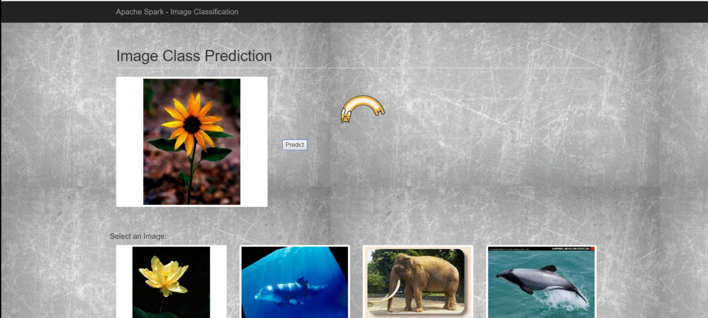  
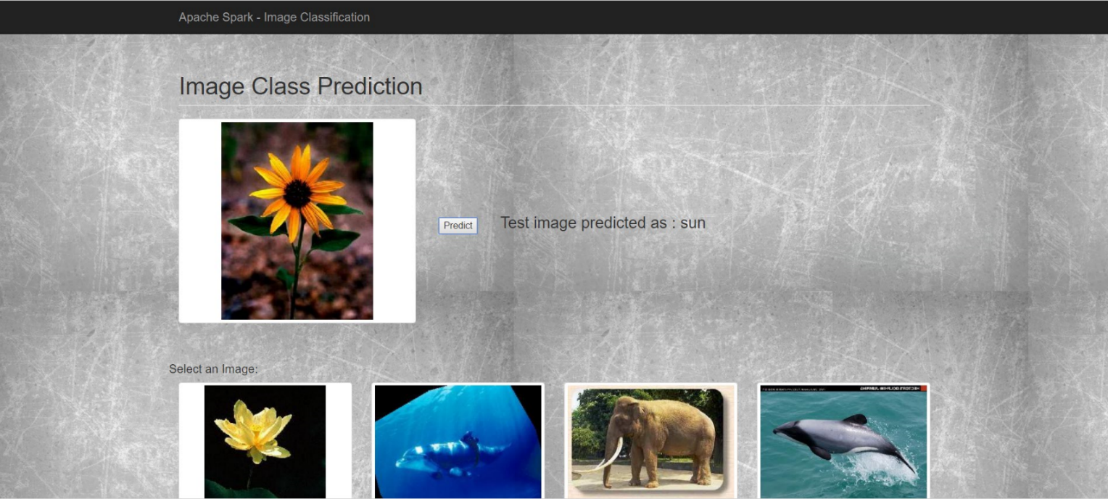  
The predicted image sun is displayed in spark console which is fetched to the client.

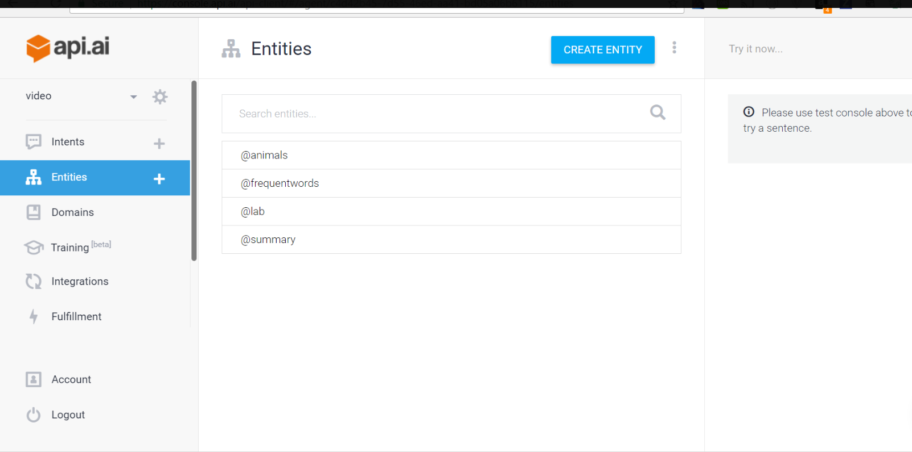

**Intent Creation**  
An intent represents a mapping between what a user says and what action should be taken by your software.  
Intent interfaces have the following sections:  
User says  
Action  
Response  
Contexts  
We have created intents as below.  
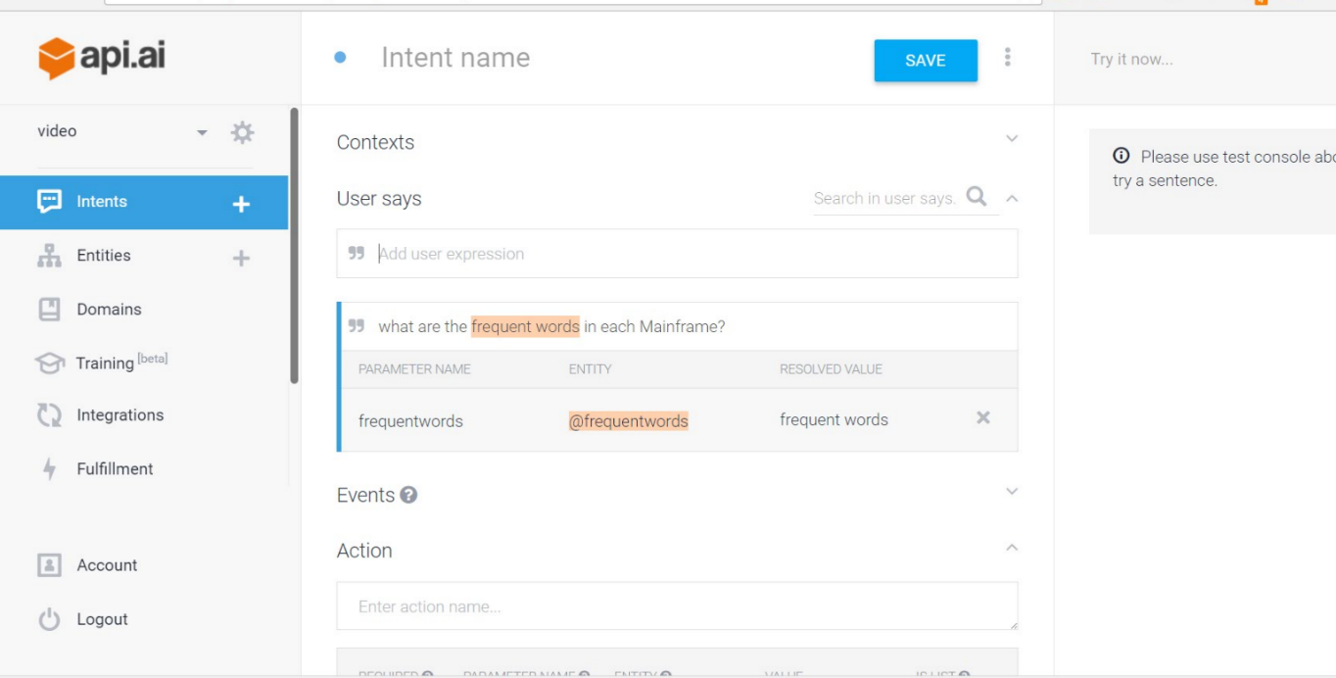

**Conversation**  
